**ABAP - External Debugging**

**Main Steps:**

1. **RFC Connection - 800 Source system**
2. **Remote Function Module - 800 Source system**
3. **Create a Program to call Remote Function Module - 800 Source system**
4. **Debug External Client/System. 810 Target.**

**Main Step - RFC Connection - 800 Source system**

**Step # 1: Go to T-Code: SM59 and create RFC Connection.**

**If the RFC connection is a Type 3 connection. Check under ABAP Connection hierarchy**

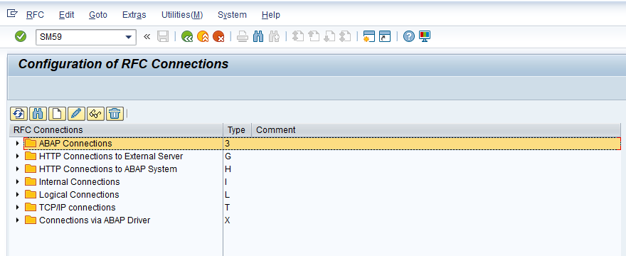

**Step # 2: Place the cursor on ABAP Connections and click on create button.**

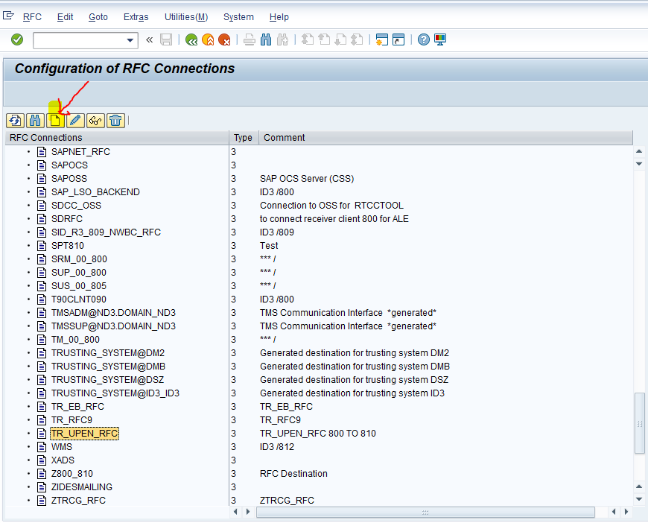

**Step # 3: RFC Destination name should be case sensitive TR_UPEN_RFC and provide the short description. And click on logon & Security Tab. And provide the target client/server details as per the requirement and save it.**

**Language:** EN

**Client:** 810 – Target Client Number.

**User ID;** ABAPTR - Target Client SAP login User ID.

**Password:** Target Client SAP login password.

Click on Remote Logon to check the target client connection.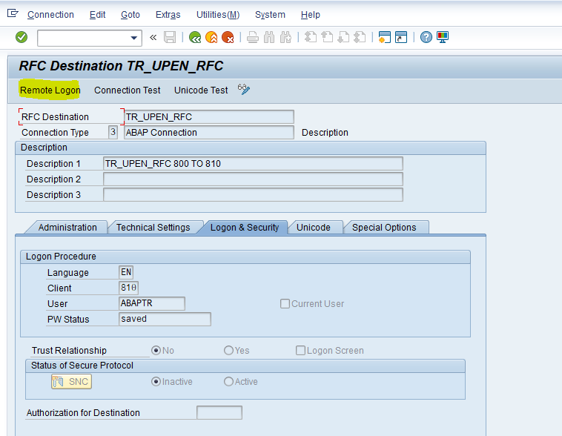

**Step # 4:** Check the client no 810 in the status bar – Remote login was successfully connected and click back button to come back (logoff) to the source system.

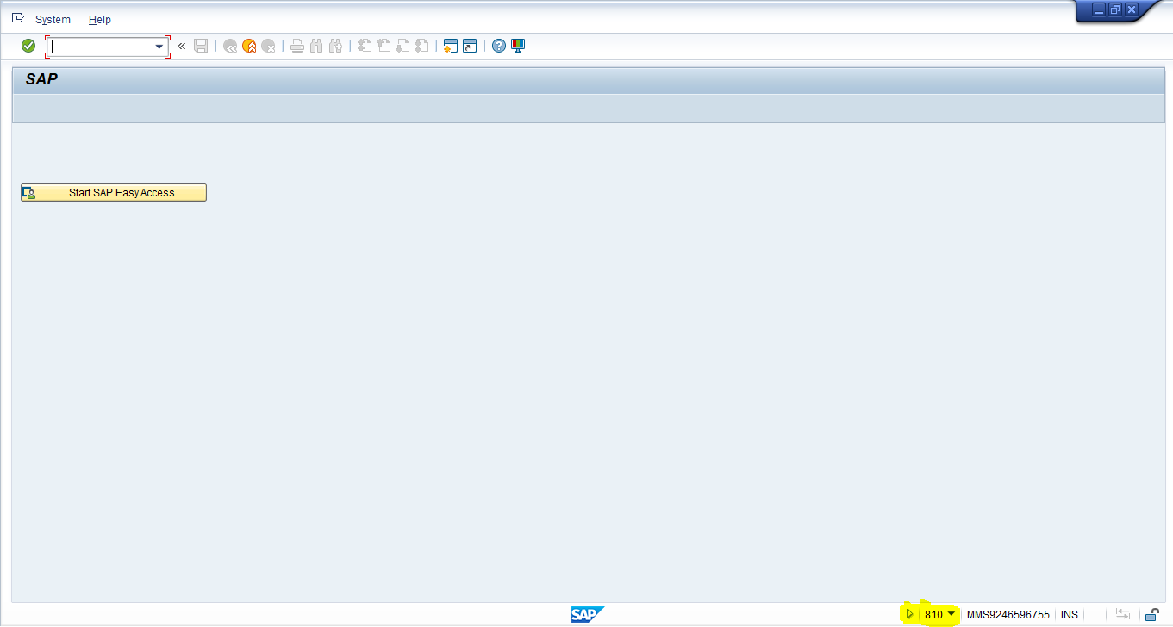

**Step # 5: Check the connection test.**

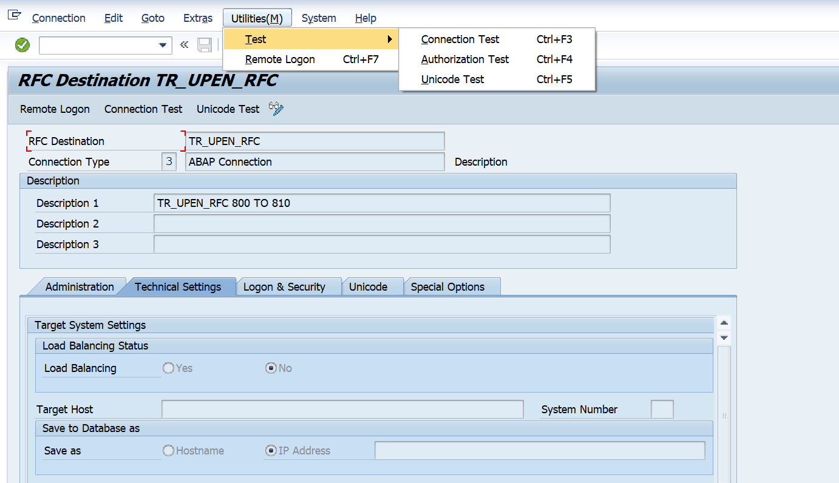

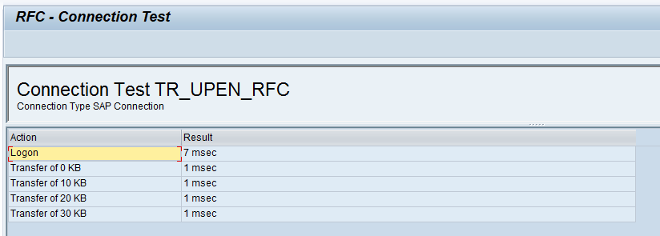

**Connection test 🡪 If this is successful it shows the response to call the other system or throws an error.**

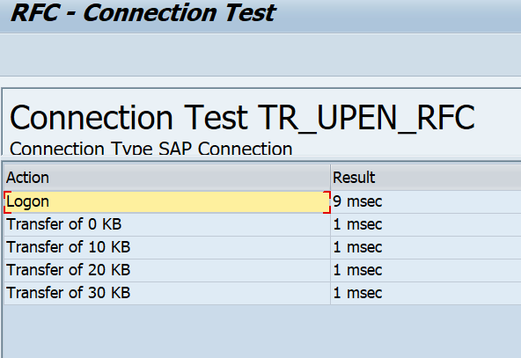

**Authorization test 🡪 If this is successful it shows the same screen as Connection test**

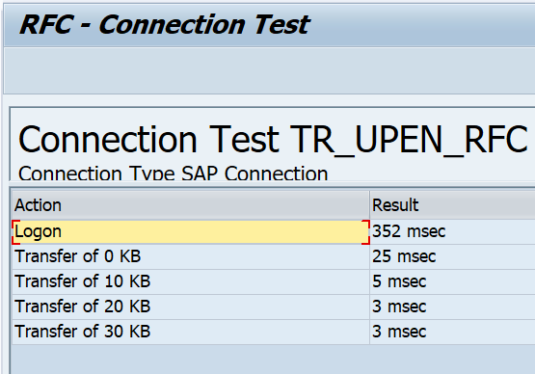

**Unicode Test ->** It is to check if the Target system is a Unicode or not.

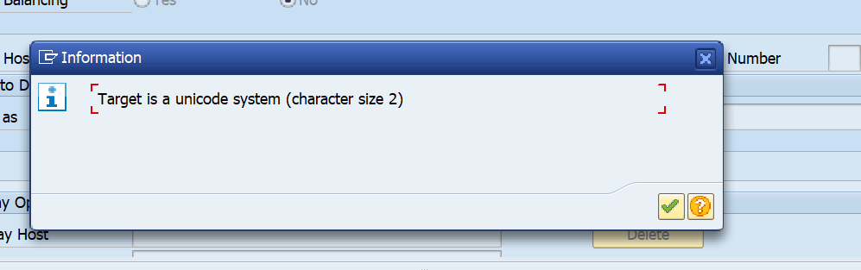

**Remote Logon 🡪** In this test, we need to specify a login ID and Password (if not provided under ‘Logon and Security’ tab). If the user is of type ‘Dialog’ then a dialog session is created. If the test is successful, the target system screen appears

And click on SAP easy Access

The target system is connected with this RFC Steps was completed.



**II) Main Step – Remote Function Module - 800 Source system**

Step # 1; create a structure.

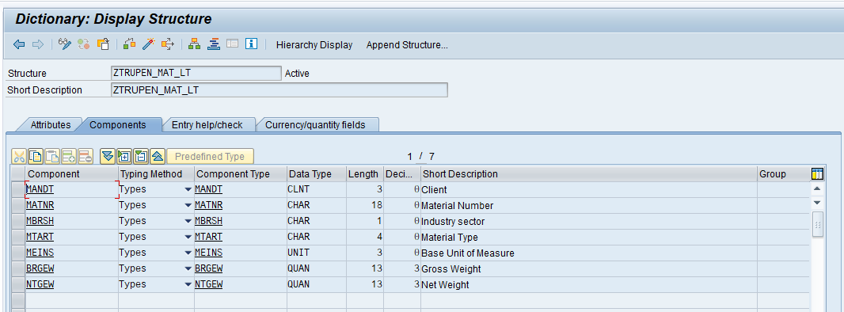

Step # 2; create a table type and add the structure as a line type.

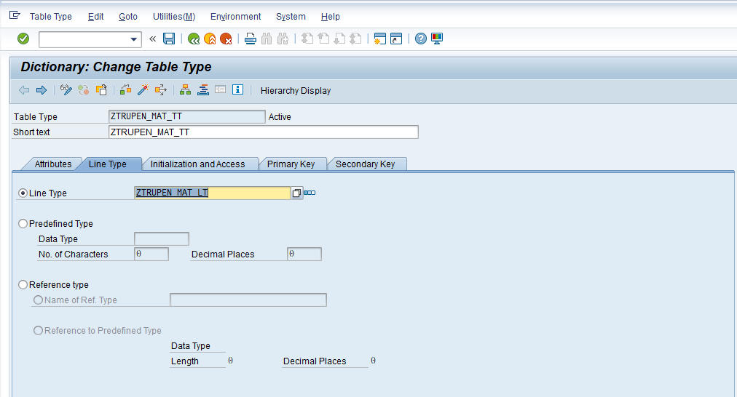

Step # 3; Go to SE37 T- Code and Create a RFC Function Module by selecting the second radio button I.e Remote-Enable Module.

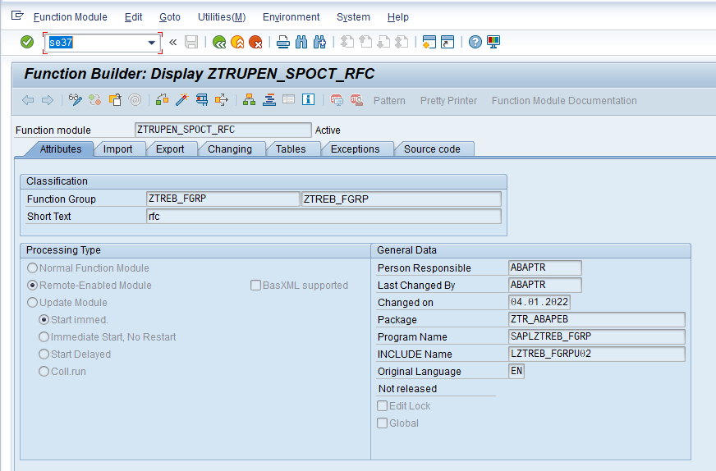

Step # 4; Click on Import tab and provide the details.

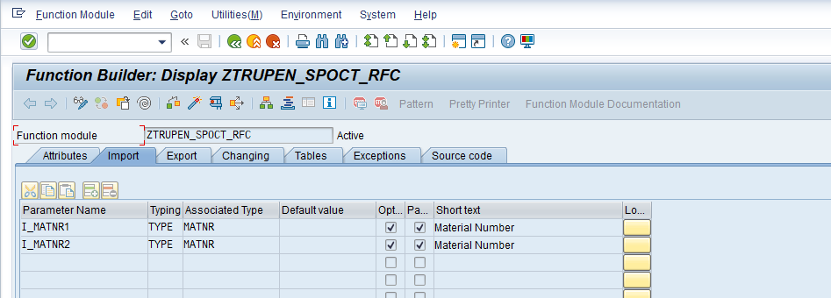

Step # 5; Click on Tables tab and provide the details.

Note: Associated type ZTRUPEN_MAT_TT was table type.

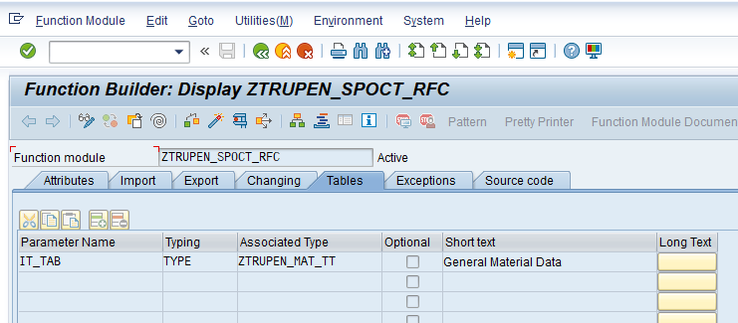

Step # 6; write the FM source code.

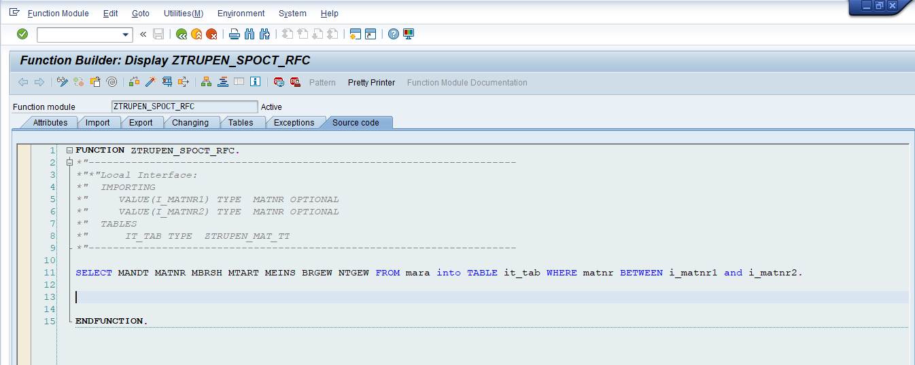

1. **Main Step - Create a Program to call Remote Function Module - 800 Source system**

Step # 1; create a program in source system (800 – Client) to call RFC function module and get the data from remote target system (810 client) when you run this program.

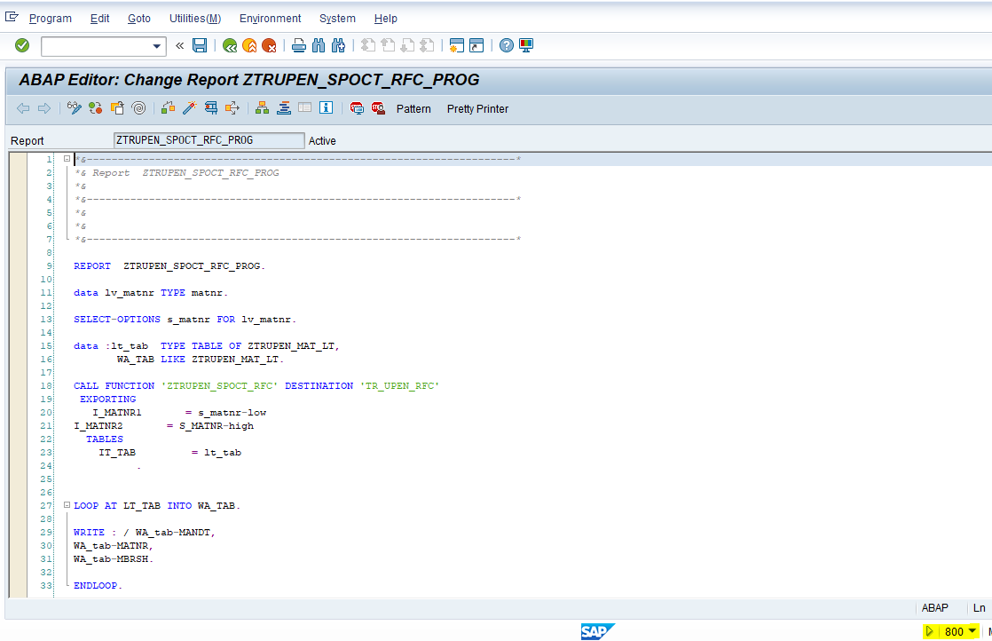Code:

*&---------------------------------------------------------------------*  
*& Report  ZTRUPEN_SPOCT_RFC_PROG  
*&  
*&---------------------------------------------------------------------*  
REPORT  ZTRUPEN_SPOCT_RFC_PROG.  
  
data lv_matnr TYPE matnr.  
  
SELECT-OPTIONS s_matnr FOR lv_matnr.  
  
data :lt_tab  TYPE TABLE OF ZTRUPEN_MAT_LT,  
       WA_TAB LIKE ZTRUPEN_MAT_LT.  
  
CALL FUNCTION 'ZTRUPEN_SPOCT_RFC' DESTINATION 'TR_UPEN_RFC'  
 EXPORTING  
   I_MATNR1       = s_matnr-low  
I_MATNR2       = S_MATNR-high  
  TABLES  
    IT_TAB         = lt_tab  
          .  
  
LOOP AT LT_TAB INTO WA_TAB.  
  
WRITE : / WA_tab-MANDT,  
WA_tab-MATNR,  
WA_tab-MBRSH.  
  
ENDLOOP.

Step # 2; the output of the RFC program at source system and can check the client no 810 was displayed and the data was displayed from the 810 clients.

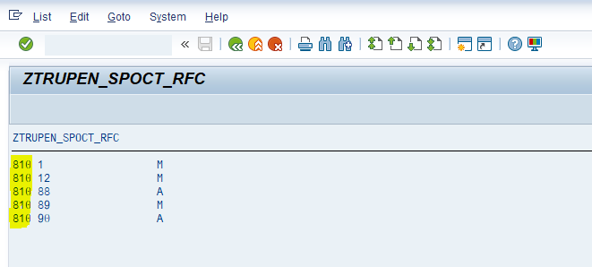

1. **Main Step - Debug External Client/system. 810 Target Client.**

After RFC test is successful i.e. (**Main Step - RFC Connection - 800 Source system)**

Open the RFC Function Module in the target system 810 Client.

1. The ABAP user that used to log on to the target system with, and the user of the source system which process the requests both should be available for debugging rights.

Choose Utilities 🡪 Setting🡪 ABAP Editor🡪Debugging.

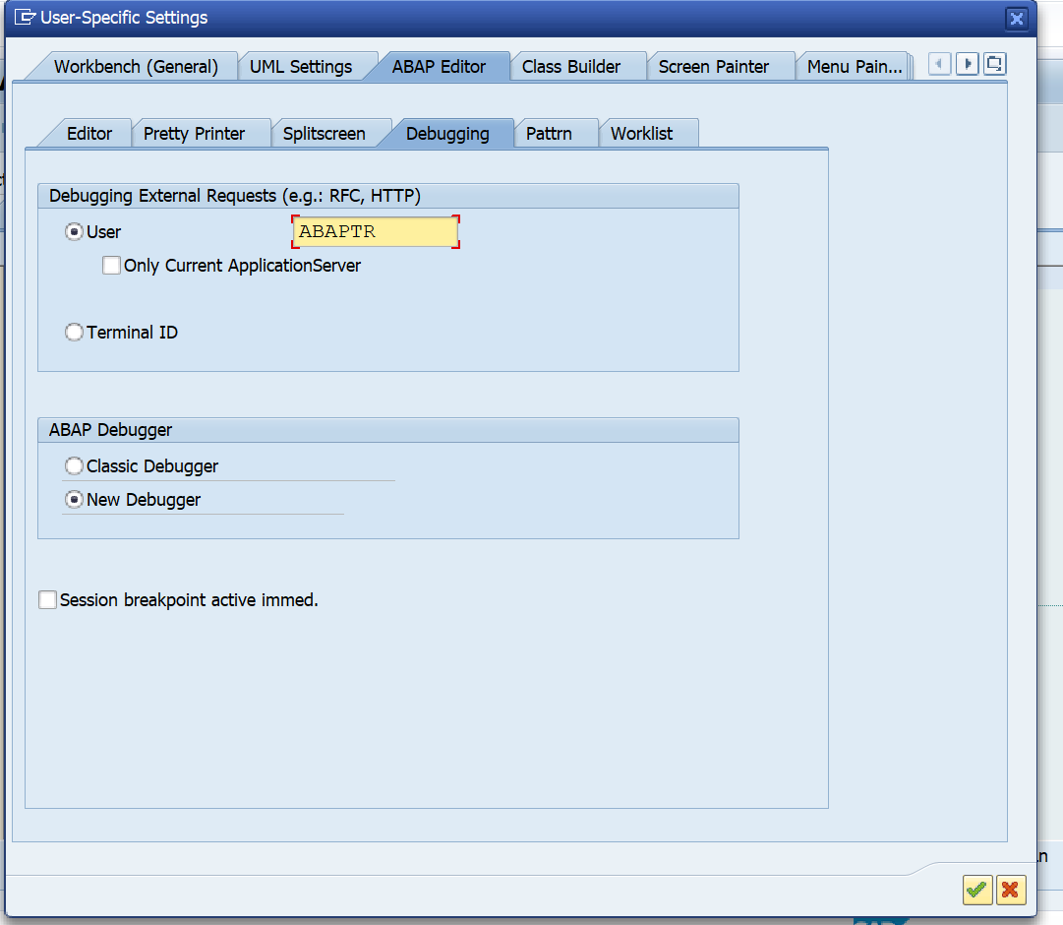

Apply the above settings and click on continue.

Step 2: Place the cursor on the FM source code (810 Client) to set the external breakpoint and click on icon (marked in red) to set External Break point.

External Break points are active for Two Hours only. Later they are deactivated.

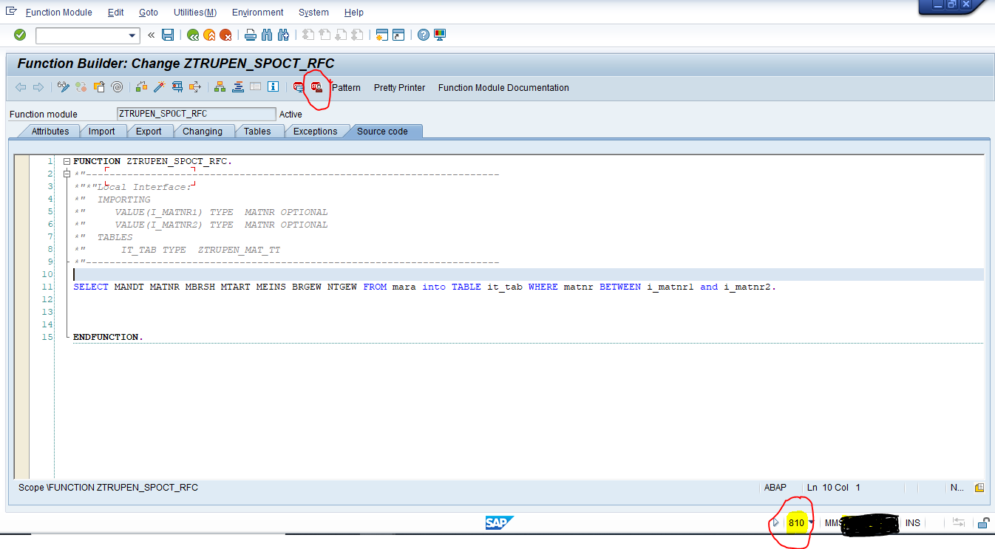

Code: SELECT MANDT MATNR MBRSH MTART MEINS BRGEW NTGEW FROM mara into TABLE it_tab WHERE matnr BETWEEN i_matnr1 and i_matnr2.

Now external breakpoint is set in the RFC FM of the target system.

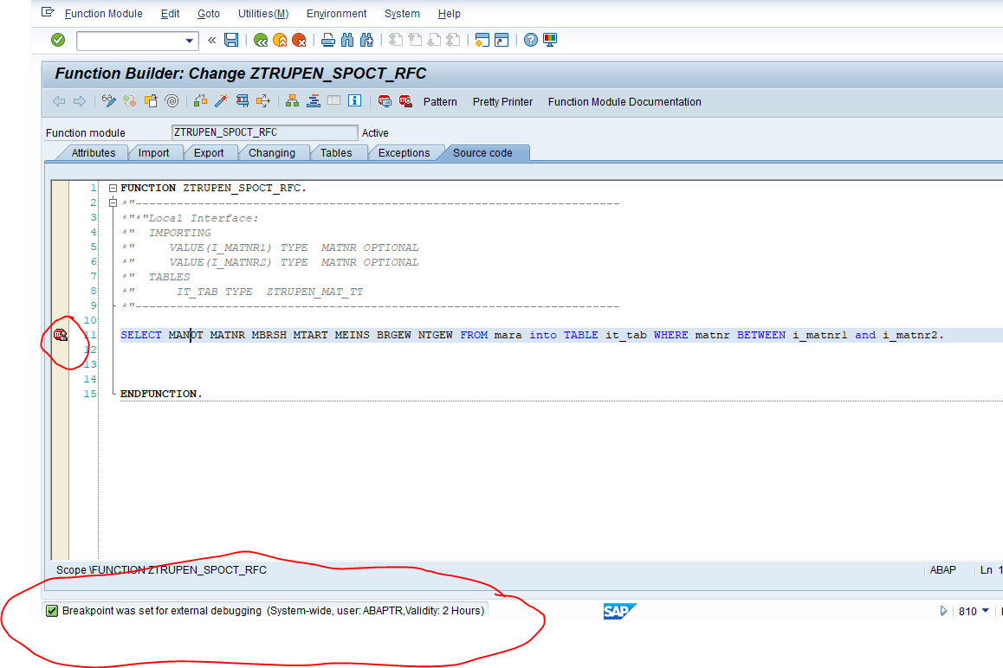Step 4: Now in the source system (800 Client) of RFC Connection, go the program which calls the RFC FM in the target.

Go to T-Code: SE38 and execute the program

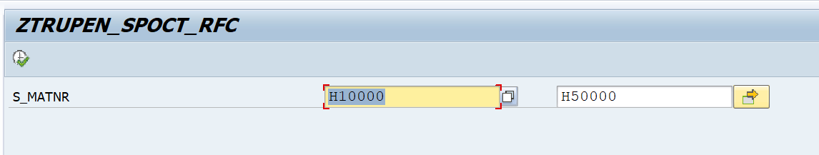

Since the external breakpoint is set, it executes in debugging and goes to the external breakpoint in target system 810.

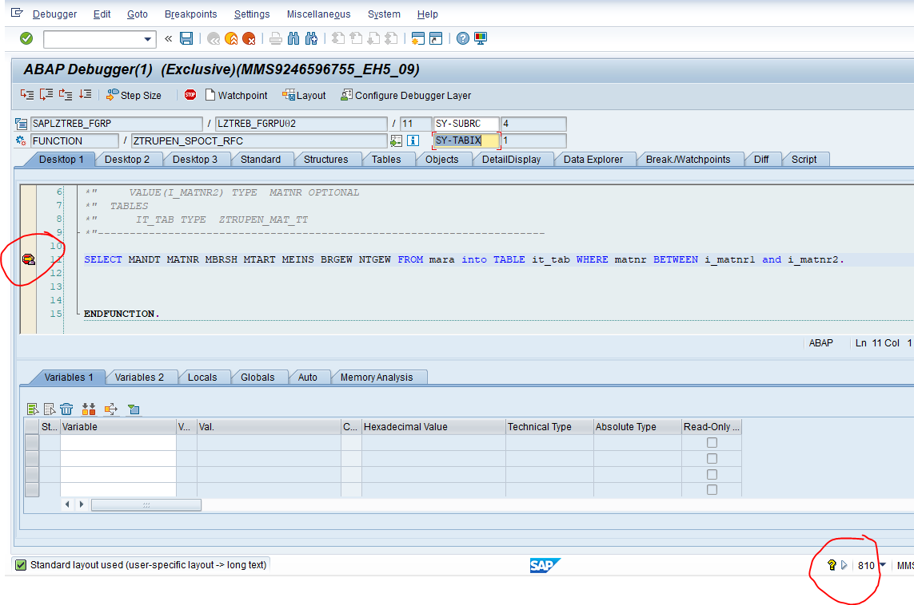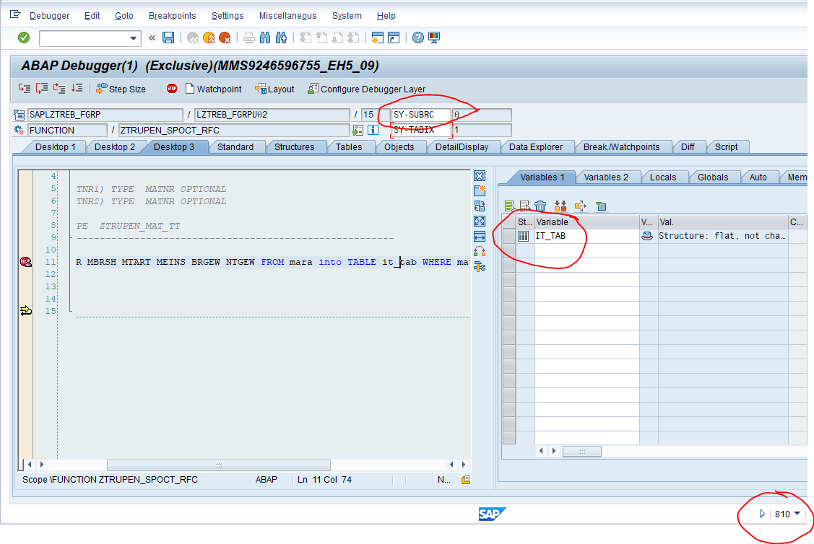

Output: Press F8 …. the result from the source system.